Author

University or Organization

Email address

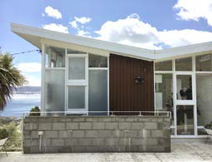

Image description (plus reference). Please right click to ‘change picture’

Abstract of no more than 250 words, accompanied by a single image of author’s chosen building (caption plus reference), should be submitted along with the applicants name, email address, professional affiliation, and brief 50- word Biography.

Label this file: THEME-SURNAME_Firstname-Title

1